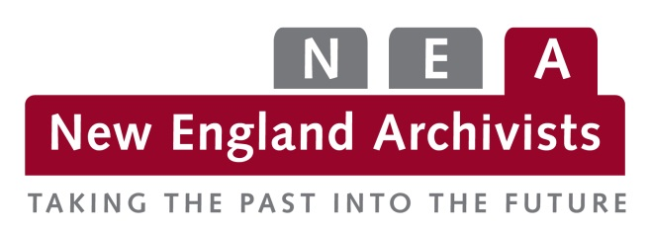

Petition to Establish a Roundtable
Roundtables may be initiated through a petition to the Board from at least 10 NEA members in good standing. Petitions to establish Roundtables may be submitted for approval at any of the quarterly Board meetings; petitions must be submitted to the NEA secretary no less than 10 working days prior to the Board meeting at which it will be voted on. Roundtables are officially established by majority vote of the Board, approval of a proposed Roundtable’s goals and objectives, and approval of a liaison between the specific Roundtable and the Board.

Roundtable Name:

Chair/Liaison:

Proposed Goals and Objectives:
Each proposed roundtable shall create and adopt a statement of goals and objectives of the roundtable and its members. These goals and objectives should address the proposed focus of the group and may address specific functions, activities or issues. All statements of goals and objectives must reflect the bylaws, policies and procedures of New England Archivists. Goals and objectives may be changed as a majority of the membership of the roundtable sees fit.

Members:
Include here the signatures (print or electronic) of at least 10 NEA members in good standing.
1. | 16.
2. | 17.
3. | 18.
4. | 19.
5. | 20.
6. | 21.
7. | 22.
8. | 23.
9. | 24.
10. | 25.
11. | 26.
12. | 27.
13. | 28.
14. | 29.
15. | 30.

Date submitted to Board:

